**Digital Communication 2  
Project activity report**Marco Ceran

2020-2021

**Introduction**

The goal of this project activity is to implement an adaptive predistortion communication system in the Simulink software environment. In this system an adaptive predistorter precedes a non-ideal amplifier to compensate for its non-ideality. Various metrics and the relations between them are then evaluated. Examples of those metrics are Crest Factor, Output Back-Off, Signal-to-Distortion ratio, but Power Spectral Densities graphs and convergence values of the predistortion characteristic coefficients are also evaluated to assess the correct behaviour of the system.

**System structure and implementation**

The system starts with a pair of random number generator that output real values with Gaussian distribution and unitary power (we used the random number block in Simulink, and it is important to specify different seeds in order to get different numbers because this program uses a pseudo-random number generation pattern). The outputs of those two blocks are then sent to Raised Cosine Transmit Filters (name of the block) with roll-off factor 0.2, oversampling factor 8 (meaning that the frequency is 8 times the Nyquist frequency) and unitary gain. Those two signals are now combined to become the real and imaginary part of a complex number that has thus power equal to 2, that is the sum of the unitary power values of the real and imaginary part. We then multiply this complex signal by a factor λ (lambda) that is one of the tuning parameters of the system.

The next part is the crest reduction block, that caps the modulus of the complex signal to one, and does this by separating the phase and modulus of the signal, passing the modulus through a hard clipper (or limiter), and recombining it with the unchanged phase. This operation is a nonlinear one that adds distortions to the signal, but it’s crucial to control the crest factor of the system (that is the squared maximum modulus of the signal over the average power of it).

The crest reduced signal is subsequently fed to the predistortion block, that does not change the phase of the signal, but it changes the modulus by passing it through a piecewise linear characteristic (a characteristic that is obtained by dividing the interval from 0 to 1, that is the range of possible values of the modulus of the input, into N-1 equal length parts, with N being the vector length, and having a piecewise linear function crossing the N interval extremes at the values of the a vector), whose values depend on a vector athat is iteratively updated with a stochastic gradient descent algorithm.

The adaptation block executes this task, by updating one of the values of the a vector per iteration, with this relation:

Simulations have found that even if the above expression has complex components in it, the resulting values of the parameters a have the imaginary part equal to zero, resulting in practice in real values of a.

In the Simulink model we used for the implementation of the iterative procedure a clock and a constant input with the initial value of the vector, along with a delay blocks, to avoid algebraic loops and making the system work correctly from a timing standpoint.

The last block implements the very simple Rapp amplifier model, with saturation power fixed to 1, smoothness factor 2.5. This is the Rapp model characteristic:

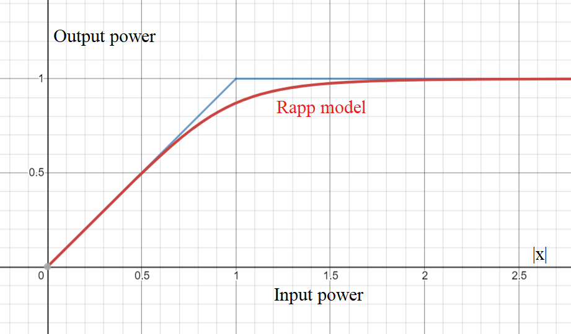

Unless otherwise stated, s indicates the source signal, x indicates the output signal of the crest reduction block, y indicates the output signal of the predistortion block and z indicates the output signal of the amplification block, while a indicates the vector of parameters that define the predistortion block’s characteristic.

**Graphs and practical results**

**Predistorter parameters:**

The vector a of parameters that define the characteristic of the predistorter gain has chosen to be of size 10, and each of its elements has been initialized to the value of 1. In order to experience how high values of the amplificator gain K drive the predistorter characteristic to divergence the λ parameter has been set to a value that causes the Crest Factor of the x signal (signal after crest reduction) to a value of 7.9 dB. Then the K parameters was tuned from 0.8 to 1.2 and divergence was experienced for values above K = 1. This table contains the values of the a vector that were found:

|  |  |  |  |  |  |  |  |
| --- | --- | --- | --- | --- | --- | --- | --- |
| **K** | 0.8 | 0.87 | 0.93 | 1 | 1.07 | 1.13 | 1.2 |
| **a[1]** | 0.95 | 0.97 | 0.98 | 1.00 | 1.06 | 1.13 | 1.19 |
| **a[2]** | 0.79 | 0.87 | 0.93 | 1.00 | 1.07 | 1.13 | 1.20 |
| **a[3]** | 0.80 | 0.87 | 0.93 | 1.00 | 1.07 | 1.13 | 1.20 |
| **a[4]** | 0.80 | 0.87 | 0.93 | 1.00 | 1.07 | 1.13 | 1.20 |
| **a[5]** | 0.80 | 0.87 | 0.93 | 1.00 | 1.08 | 1.14 | 1.21 |
| **a[6]** | 0.80 | 0.87 | 0.94 | 1.01 | 1.09 | 1.15 | 1.23 |
| **a[7]** | 0.81 | 0.88 | 0.95 | 1.03 | 1.11 | 1.21 | 1.30 |
| **a[8]** | 0.82 | 0.90 | 0.97 | 1.07 | 1.18 | 1.29 | 1.43 |
| **a[9]** | 0.83 | 0.92 | 1.02 | 1.16 | 1.38 | 5+ [D] | 11+ [D] |
| **a[10]** | 0.87 | 1.00 | 1.17 | 2.30 | 10+ [D] | 15+ [D] | 18+ [D] |

The [D] notation indicates divergence, the values reported for elements of the a vector that diverged are approximations of the values that those elements had after a longer simulation, but their true values are likely higher than that, because those values were still growing long after the other values had converged to a stable value.

The graphic representation of the input-gain characteristic of the predistortion block is reported in the following graph:

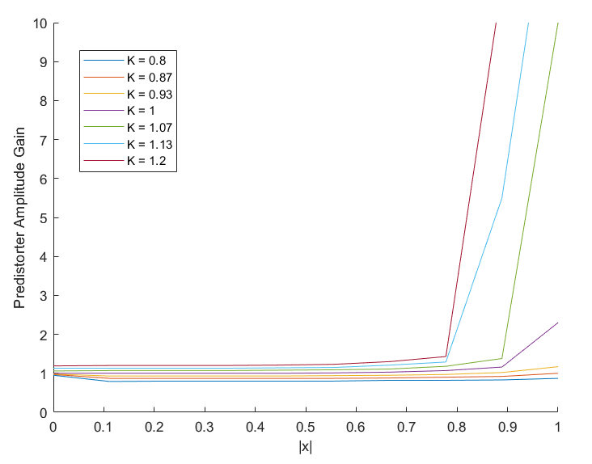

Divergence of elements of a happens for values of K higher than 1, while for lower values the characteristics are well contained in the 100 and 101 orders of magnitude, generally with higher gains for higher moduli of the input, to compensate for the Rapp model characteristic that has declining gains for higher values of |x|.

**Complex input case:**

With a complex source signal, with both real and imaginary part having a gaussian distribution, an amplification of K2 = 0.977 and CFx ≈ 7.9 dB those are the spectra that were found for x, λs, y and z:

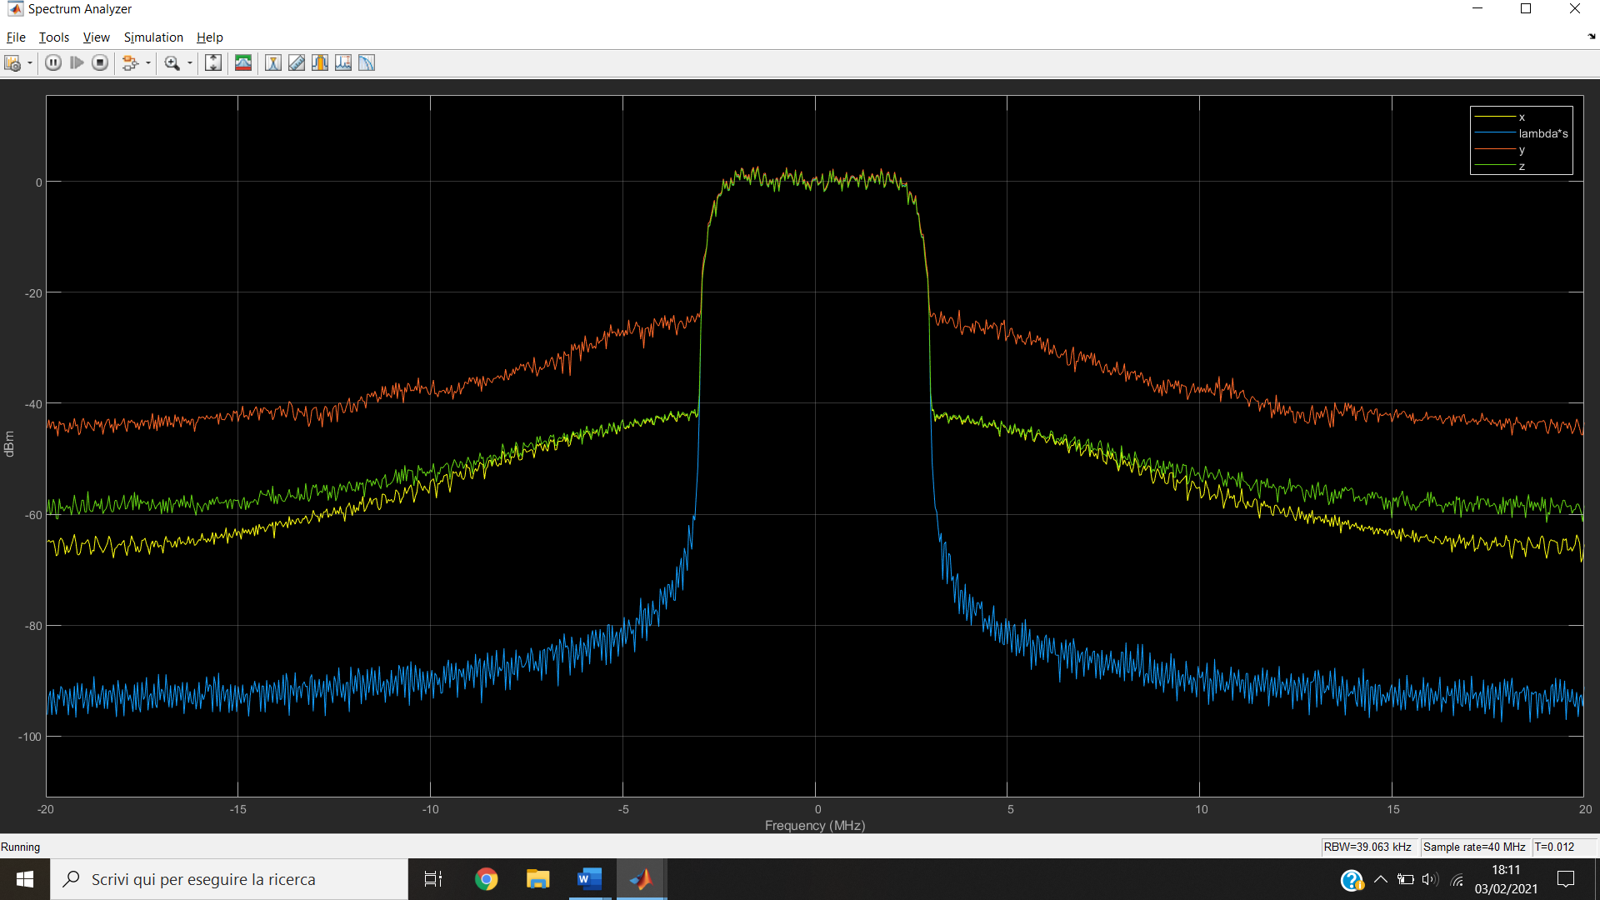

We can see that the crest factor reduction adds distortion to the spectrum of the signal (because the PSD values at higher frequencies increase) and that the predistortion adds even more distortions to it (the PSD has even higher values at higher frequencies), but after the amplification block the signal spectrum returns to a similar level to the one of x, less so at very high frequencies.  
The following graph shows the compared spectra of the signal z with and without the predistortion:

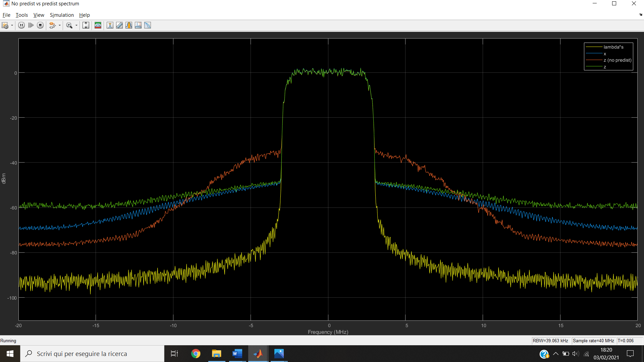

This last graph compares the non-linear distortions that are applied with the crest reduction block (λs - x) and the ones that are applied to the signal after the cascade of crest reduction, predistortion and amplification (λs – x/K):

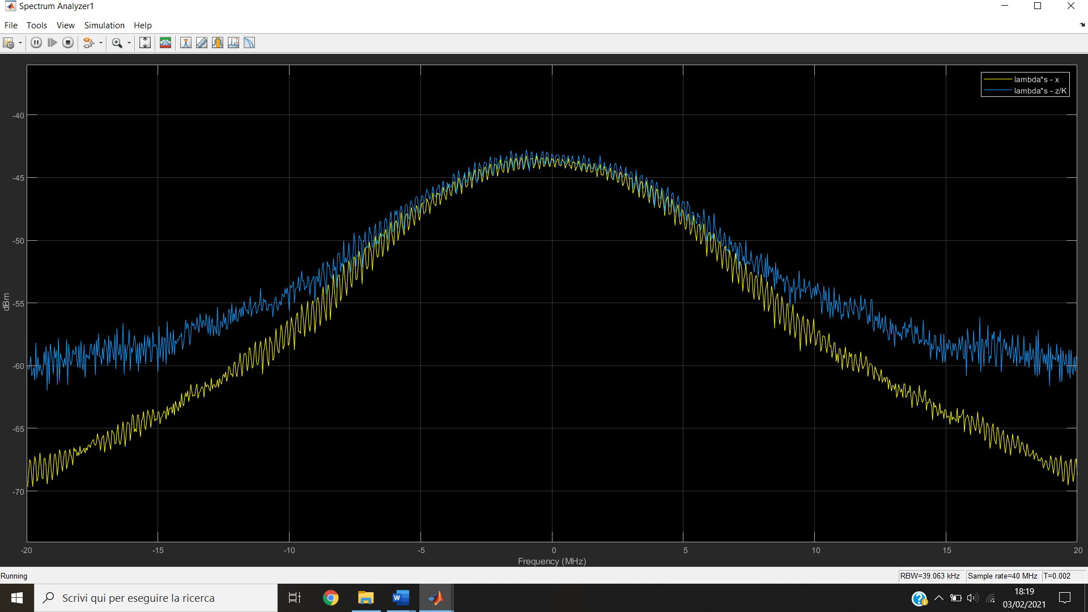

An important metric to quantify the distortions added in the system is the Signal-to-Distortion Ratio, defined as:

So, once fixed K2 to 0.977, the λ parameter has been tuned to experience how the SDR parameter varies with OBO, and the following parameters have been found:

|  |  |  |
| --- | --- | --- |
| **λ** | **OBO (CFx + 0.1 dB)** | **SDR** |
| 1.2 | 4.8 dB | 20.8 dB |
| 1.1 | 5.4 dB | 23 dB |
| 1 | 6.2 dB | 26.9 dB |
| 0.9 | 7.0 dB | 31.3 dB |
| 0.81 | 7.8 dB | 35 dB |
| 0.7 | 9.2 dB | 43.7 dB |
| 0.6 | 10.6 dB | 50.1 dB |

From those values the following characteristic derives:

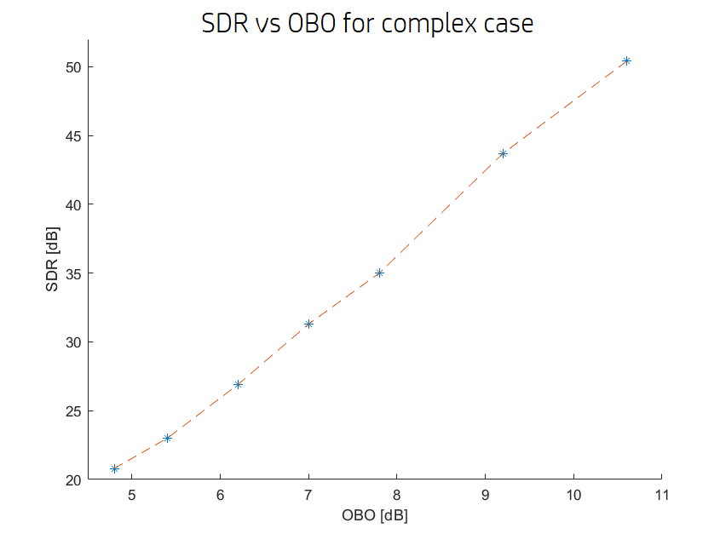

**Real Input case:**

The same graphs and operations that have been shown before for the complex input case are now repeated with a real input, generated with the same method as the complex one (Gaussian random number generator with unitary power passed through a raised cosine transmit filter), but only for the real part, as the complex part has been set to 0. As a consequence of this, the s source signal (before multiplication with λ) has half the power of the complex case, because power of the real and imaginary part of signal are additive. Higher values of λ are needed to get the same crest factor values of the complex case, to compensate the lower power of s.

For K2 = 0.977 and λ = 1 a CF of 9.1 dB was obtained (in the complex input case this value of CF was obtained with the same K and λ = 0.7, because of the power difference of the two cases), and the vector a converged to:

|  |  |  |  |  |  |  |  |  |  |
| --- | --- | --- | --- | --- | --- | --- | --- | --- | --- |
| **a[1]** | **a[2]** | **a[3]** | **a[4]** | **a[5]** | **a[6]** | **a[7]** | **a[8]** | **a[9]** | **a[10]** |
| 0.99 | 0.99 | 0.99 | 0.99 | 0.99 | 1 | 1.01 | 1.05 | 1.12 | 1.61 |

The spectra of s, x, y and z are here reported:

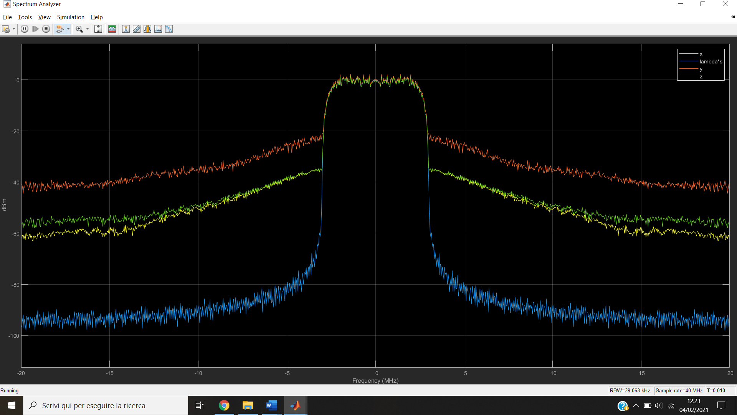

The following graph compares the spectra of the z signal with and without adaptive predistortion: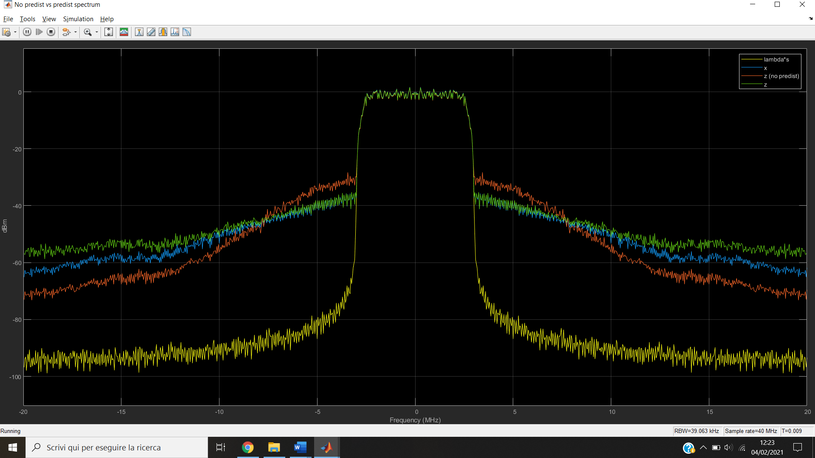

This last graph compares the distortion added to the signal after the crest reduction block, and those added after the cascade of crest reduction, predistortion and Rapp amplification:

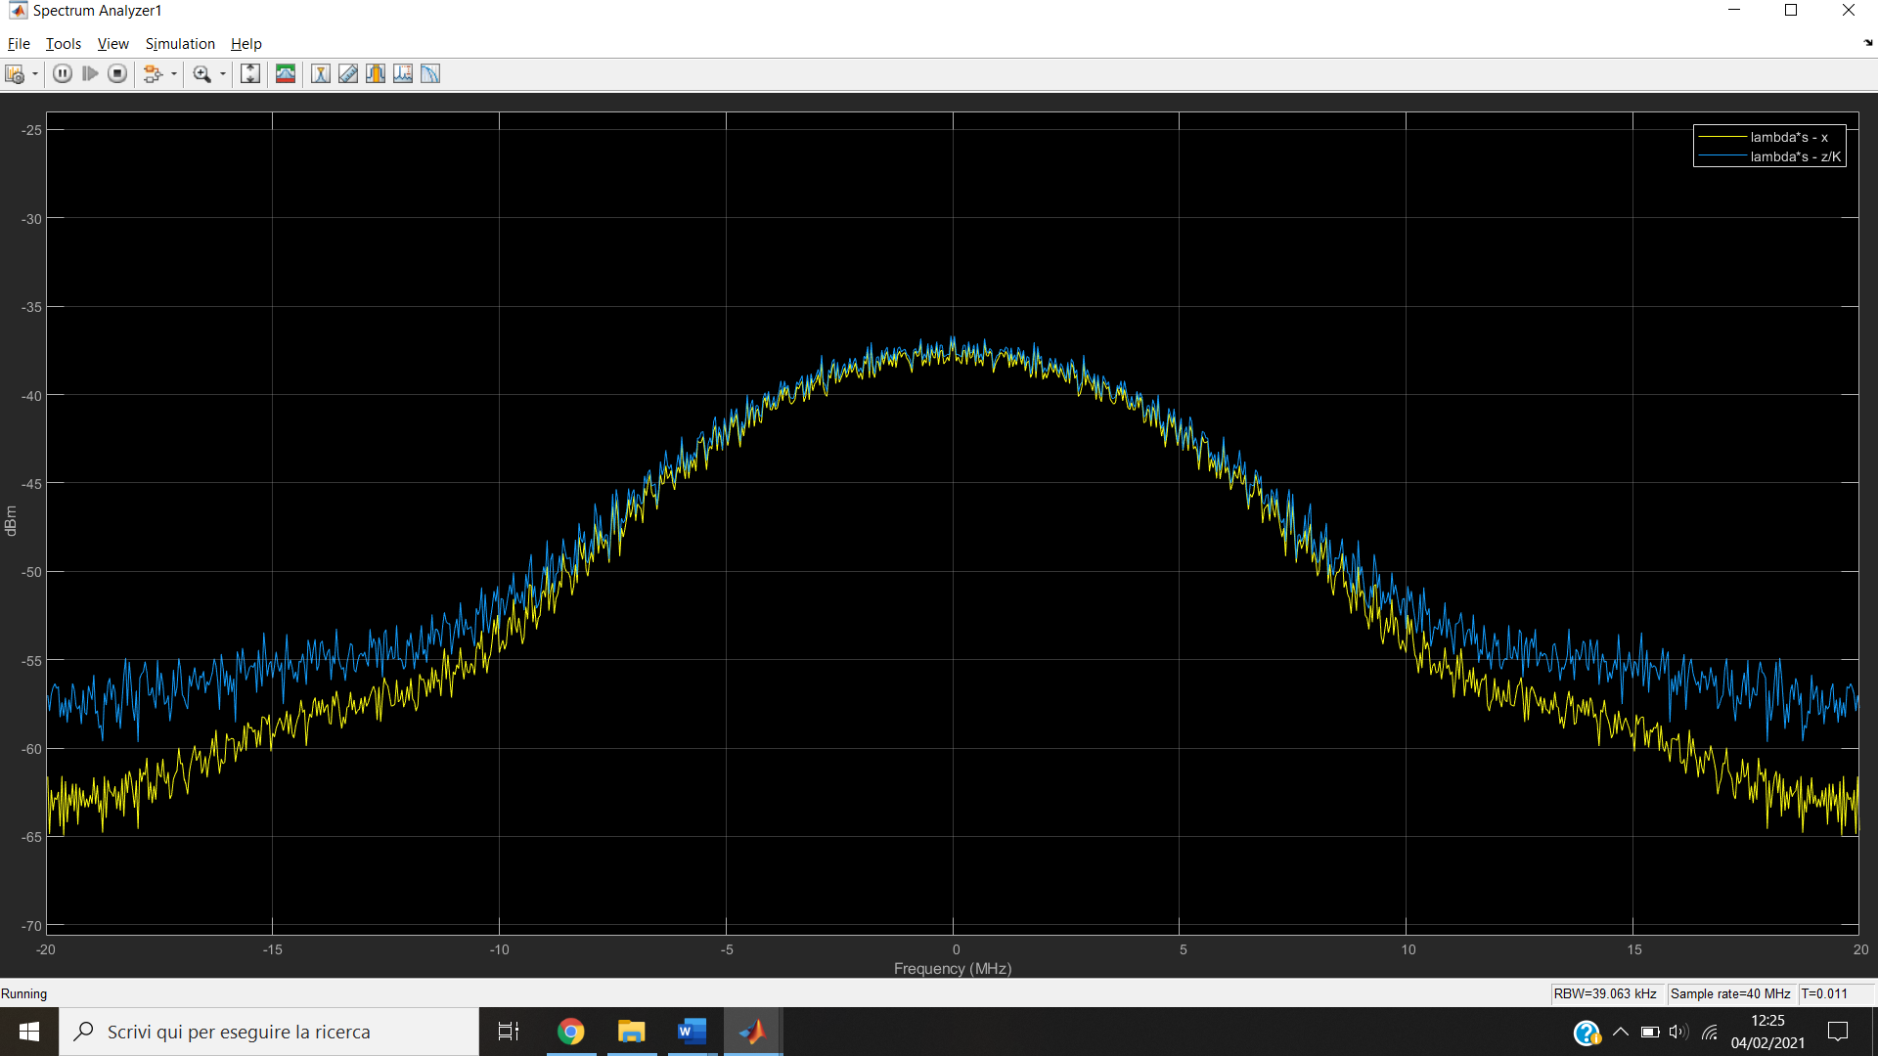

The Signal-to-Distortion Ratio (SDR) is defined for the real case in the same way as in the complex case, and once fixed K2 to 0.977, the λ parameter has been tuned to experience how the SDR parameter varies with OBO, and the following parameters have been found:

|  |  |  |
| --- | --- | --- |
| **λ** | **OBO (CFx + 0.1 dB)** | **SDR** |
| 1.4 | 6.5 dB | 19.4 dB |
| 1.3 | 7.1 dB | 21.5 dB |
| 1.2 | 7.7 dB | 23.7 dB |
| 1.1 | 8.4 dB | 26.5 dB |
| 1 | 9.2 dB | 30 dB |
| 0.9 | 10.1 dB | 34.9 dB |
| 0.8 | 11.2 dB | 40.2 dB |
| 0.7 | 12.3 dB | 41.4 dB |

Those values lead to the following SDR-OBO characteristic:

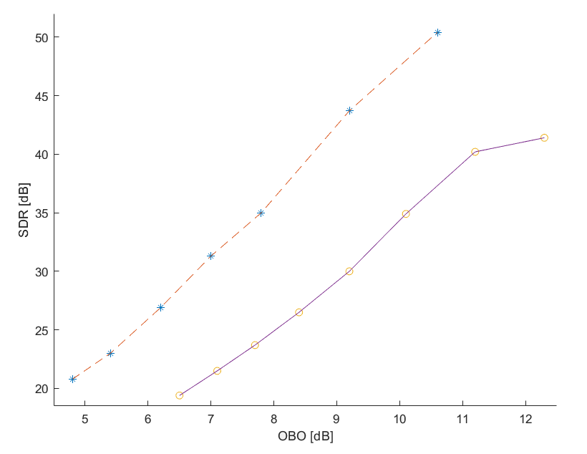

The real case characteristic is the one with the dots and the solid line, but the complex case characteristic (the one with stars and dashed line) is also showed for comparison.

**Conclusions**

This adaptive predistortion system has shown to be successful at compensating the non-ideality of the Rapp model amplifier for gains not superior to 1, where the high values of K drive the adaptation block to divergence, and the differences in the comparison between real and complex case mainly arise from the lesser power of the real case due to having only one dimension instead of 2. In both real and complex case the system was able to keep the spectrum of the z signal under -40 dB in most of the high frequency region.